
Near Light is an instrumental post-rock band from the UK founded in 2012 by two lifelong friends, Matthew Sims and Michael Davies. Their debut self-titled EP garnered critical acclaim, showcasing a unique interpretation of the post-rock genre that "offers such meaningful instrumentation that the mind is set on fire with more imagery than a thousand words could express."

After a decade-long hiatus, Near Light began their resurgence in 2024. With their evolved sound and renewed lineup, including original guitarist Steve Sims and newcomers Jon Sims and Rick Howard, Near Light is poised to enchant audiences once more, weaving intricate musical tapestries that speak volumes without uttering a single word.

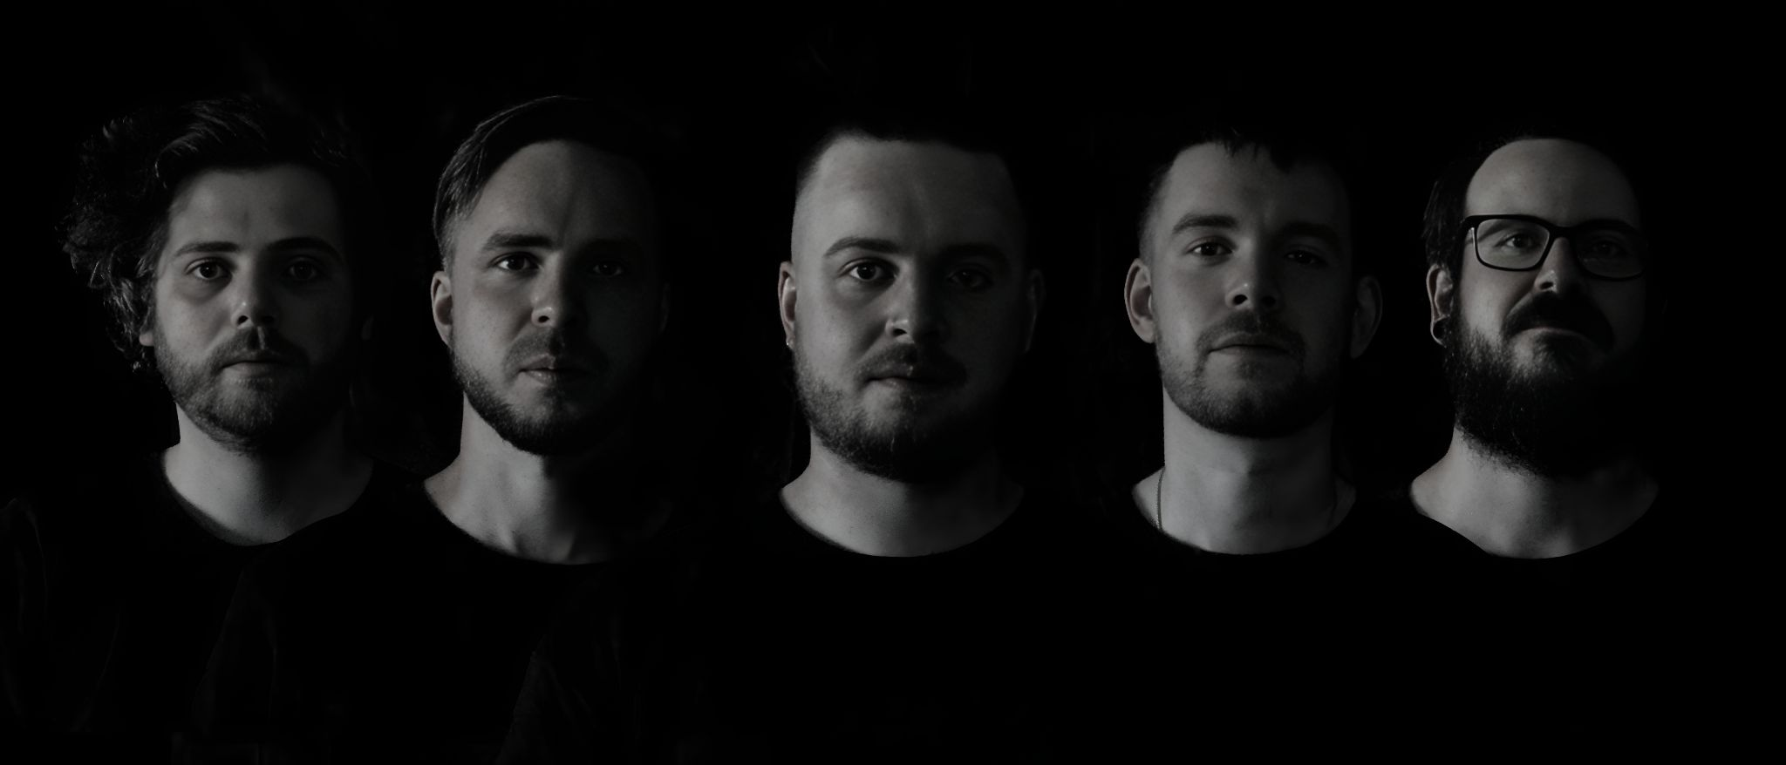
Following an invitation to join the roster at Angoal Music (China) and perform at Offside Festival, Asia’s largest post-rock festival, alongside Sleepmakeswaves, U137, Kwoon, Sleep Dealer and many more genre heavyweights, their story is only just beginning.
